Re-characterizing disturbance regimes in fire-prone forests: why severity can be misleading

Brandon M. Collins1, 2*, Peter M. Brown3, Jens Stevens4, Scott L. Stephens5, Malcolm North1,4, Hugh Safford 6 ,7

1USDA Forest Service, Pacific Southwest Research Station, Davis, CA, 95618, USA

2Center for Fire Research and Outreach, University of California, Berkeley, CA, 94720-3114 USA

3Rocky Mountain Tree-Ring Research, 2901 Moore Lane, Ft Collins, CO 80526, USA

4Department of Plant Sciences, University of California, Davis, CA 95616, USA

5Ecosystem Sciences Division, Department of Environmental Science, Policy, and Management, University of California, Berkeley, CA, 94720 USA

6USDA Forest Service, Pacific Southwest Region, Vallejo, CA 94592, USA.

7Department of Environmental Science and Policy, University of California, Davis, CA 95616, USA

*Author to whom correspondence should be addressed: e-mail: bcollins@berkeley.edu

**Abstract**

We.

**Introduction**

Departure in vegetation composition, structure, or pattern from a more “natural” ecosystem condition is often the basis for contemporary ecosystem restoration programs (Swetnam et al. 1999, Safford et al. 2012). Assessing the degree of departure requires fairly detailed descriptions of current (departed) and reference (natural) conditions. Extensive field data collection efforts combined with remote sensing products provide robust characterizations of current conditions, but similar detail and extent are often lacking for reference conditions. As a result, we often rely on coarser scale characterizations of reference conditions. Fire regime type (i.e., low, mixed, and high severity) is a readily used example for broadly characterizing fire occurrence and effects prior to 20th century fire suppression and exclusion policies (Agee 1998, Schoennagel et al. 2004). Each fire regime type is associated with a distinct set reference forest conditions (tree density, composition, age structure, and spatial pattern), which can be compared to current forest conditions to assess the degree of current departure (FRCC 2010).

Dendroecological reconstructions have provided a majority of the information from which historical disturbance regimes have been inferred (Romme 1982, Swetnam et al. 1985, Fulé et al. 1997, Brown et al. 1999, Swetnam et al. 1999, Taylor 2004). There are two predominant phenomena by which past disturbance events can be inferred from tree rings, through direct, non-lethal cambial injury recorded in tree ring series (e.g., fire scars) and through the formation of distinct post-disturbance cohorts. Conventionally, fire scar-based reconstructions were used in forest types historically associated with low to moderate intensity surface fires (e.g., Dieterich 1980), while stand age reconstructions were used in forest types associated with high intensity, crown fires (Heinselman 1973, Romme 1982). More recent studies, primarily from the former forest types, have coupled fire scar collections with extensive tree age structure sampling (Beaty and Taylor 2007, Brown et al. 2008, Scholl and Taylor 2010, Taylor 2010). These studies have allowed for the indirect inference to fire severity through identification of post-fire cohorts. However, many dry conifer forests have several age classes within a single stand (e.g., Beaty and Taylor 2007, Scholl and Taylor 2010), which make identification of distinct post-fire cohorts difficult. Furthermore, regeneration cohorts are not necessarily associated with fire (White 1985, Brown and Wu 2005, North et al. 2005).

Dendroecological studies do well at characterizing the two extremes of historical fire regimes in forests, i.e., frequent, low-intensity, non-lethal fires and infrequent, high-intensity, lethal fires. Example forest types with these respective fire regimes include southwestern U.S. ponderosa pine (*Pinus ponderosa*) and Rocky Mountain lodgepole pine (*Pinus contorta*) (Schoennagel et al. 2004). The problem is there are many forest types that have fire regimes somewhere in between these two extremes. These so-called “mixed-severity” forest types historically had structural components maintained by non-lethal surface fire (i.e., large, widely spaced, early-seral trees) that were intermixed with discrete vegetation patches created by crown-fire (i.e., shrubs, dense conifer stands) (Agee 1998, Hessburg et al. 2007). This is corroborated by the insightful observations of fire in un-harvested Sierra Nevada pine-mixed-conifer forests made by Show and Kotok (1924):

“[n]o large fires occur without a certain amount of heat-killing…This loss, it should be noted, represents the complete or nearly complete wiping out of small patches of the stand rather than a uniformly distributed loss over the entire area”.

The occurrence of both surface and crown fire in the same forest type historically resulted in highly complex vegetation – fire interactions, (Perry et al. 2011). This complexity along with the wide amplitude in fire effects (often described as 20-70% overstory mortality - Agee 1993, 1998) has led to considerable uncertainty identifying the historical range of variation for forests binned in the “mixed-severity” fire regime (Perry et al. 2011). This uncertainty regarding historical fire and forest conditions has spawned vigorous debate over assessments of current departure in these forest types (Brown et al. 1999, Brown et al. 2008, Williams and Baker 2012, Baker 2014, Odion et al. 2014). This ongoing debate is not simply academic; it has strong implications for forest restoration throughout the western U. S. In this paper we aim to address this uncertainty by proposing a new way to characterize historical fire regimes. The intent with this characterization is to will allow for more explicit comparison with current fire patterns to assess departure, thus better informing restoration.

**Problems with using severity alone**

Despite having widely used definitions for binning fire regimes based on average overstory mortality levels (<20%, 20-70%, >70%; Agee 1993), there is considerable ambiguity in the scale at which these mortality thresholds should be applied. At fine spatial scales most fires will have a portion of burned area in all three overstory mortality classes (Brown et al. 2008). This suggests that these thresholds are more suited for coarser spatial scale assessments, such as summarizing fire severity for individual fires or possibly multiple fires over time across a landscape (Agee 1998). The problem, however, with simply summarizing overstory tree mortality at a coarser scale is that the spatial patterns of mortality are often ignored. Large, contiguous patches of tree mortality can have a very different effect on post-fire vegetation dynamics than many smaller patches. This is particularly true for forest types in which the dominant tree species lack direct mechanisms for establishment following stand-replacing fire (e.g., vegetative re-sprouting, seed stored in serotinous cones) (Collins and Roller 2013). In these forest types tree establishment is often limited by wind-dispersal from surviving mature trees, which for most conifers is typically < 90 m (McDonald 1980, McCaughey et al. 1986). Large stand-replacing patches (e.g., >100 ha) have a disproportionate amount of area that exceeds most wind dispersal distances (Cansler and McKenzie 2014), and as a result may be void of natural conifer regeneration for a considerable amount of time (Goforth and Minnich 2008, Collins and Roller 2013).

It is possible to have relatively low overall proportions of stand-replacing effects within individual fires (e.g., 15-20%) result in very different spatial patterns of mortality. We examined three relatively recent fires in the Sierra Nevada to illustrate this point (Figure 1). The 2012 Chips Fire in the Plumas National Forest burned with what many would consider a modest overall proportion of stand-replacing fire (22%). This proportion was not too different from that observed in two previously studied Yosemite National Park (YNP) fires, which burned with 15% stand-replacing effects (Collins and Stephens 2010). The patterns of stand-replacing effects, however, were distinct. Over half of the stand-replacing area in the Chips Fire was aggregated in contiguous patches that were larger than 100 ha, which for the two YNP fires was relatively evenly distributed among patch size classes <100 ha (Figure 1). Furthermore, the YNP fires had no patches >100 ha. The potential impact of these different distributions of stand-replacing patch area on conifer regeneration is significant. Over 40% of the stand-replacing area in the Chips Fire is >90 m from patch edges, compared to 15% for the YNP fires (Figure 2). While these different patterns are clearly influenced by the disparity in overall fire sizes (Chips: 30,898 ha; YNP fires combined: 4278 ha) (also see Cansler and McKenzie 2014), they emphasize the importance in not only examining overall proportions of stand-replacing effects, but at patch sizes and the distribution of area among patch size classes.

**Alternate characterization of fire regimes**

Patch size vs. area, examples (Figures 1 and 2)

**Uncertainty with alternate approach**

We may never know the appropriate distribution for a given forest type and/or that was likely not static over time.

**Implications for forest restoration**

Patch size vs. area distribution can be applied to individual fire or summarized for multiple fires over a given area

**References**

Agee, J. K. 1993. Fire ecology of Pacific Northwest forests. Island Press, Washington D.C., USA.

Agee, J. K. 1998. The landscape ecology of Western forest fire regimes. Northwest Science 72:24-34.

Baker, W. L. 2014. Historical forest structure and fire in Sierran mixed-conifer forests reconstructed from General Land Office survey data. Ecosphere 5:art79.

Beaty, R. M., and A. H. Taylor. 2007. Fire disturbance and forest structure in old-growth mixed conifer forests in the northern Sierra Nevada, California. Journal of Vegetation Science 18:879-890.

Brown, P. M., M. R. Kaufmann, and W. D. Shepperd. 1999. Long-term, landscape patterns of past fire events in a montane ponderosa pine forest of central Colorado. Landscape Ecology 14:513-532.

Brown, P. M., and R. Wu. 2005. Climate and disturbance forcing of episodic tree recruitment in a southwestern ponderosa pine landscape. Ecology 86:3030-3038.

Brown, P. M., C. L. Wienk, and A. J. Symstad. 2008. Fire and forest history at Mount Rushmore. Ecological Applications 18:1984-1999.

Cansler, C. A., and D. McKenzie. 2014. Climate, fire size, and biophysical setting control fire severity and spatial pattern in the northern Cascade Range, USA. Ecological Applications 24:1037-1056.

Collins, B. M., and S. L. Stephens. 2010. Stand-replacing patches within a ‘mixed severity’ fire regime: quantitative characterization using recent fires in a long-established natural fire area. Landscape Ecology 25:927-939.

Collins, B. M., and G. B. Roller. 2013. Early forest dynamics in stand-replacing fire patches in the northern Sierra Nevada, California, USA. Landscape Ecology 28:1801-1813.

Dieterich, J. H. 1980. Chimney spring forest fire history. Research Paper RM-220, U.S. Department of Agriculture, Forest Service, Rocky Mountain Research Station, Fort Collins, CO.

FRCC. 2010. Interagency Fire Regime Condition Class guidebook, version 3.0. National Interagency Fuels, Fire, and Technology Transfer.

Fulé, P. Z., W. W. Covington, and M. M. Moore. 1997. Determining reference conditions for ecosystem management of southwestern ponderosa pine forests. Ecological Applications 7:895-908.

Goforth, B. R., and R. A. Minnich. 2008. Densification, stand-replacement wildfire, and extirpation of mixed conifer forest in Cuyamaca Rancho State Park, southern California. Forest Ecology and Management 256:36-45.

Heinselman, M. L. 1973. Fire in the virgin forests of the Boundary Waters Canoe Area, Minnesota. Quaternary Research 3:329-382.

Hessburg, P. F., R. B. Salter, and K. M. James. 2007. Re-examining fire severity relations in pre-management era mixed conifer forests: inferences from landscape patterns of forest structure. Landscape Ecology 22:5-24.

McCaughey, W. W., W. C. Schmidt, and R. C. Shearer. 1986. Seed-dispersal characteristics of conifers in the inland mountain West. Pages 50-62 *in* Proceedings-Conifer Tree Seed in the Inland Mountain West. U. S. Department of Agriculture, Forest Service, Intermountain Research Station, Missoula, MT. INT-GTR-203. Gen. Tech. Rep.

McDonald, P. M. 1980. Seed dissemination in small clearcuttings in north-central California. General Technical Report PSW-150, U.S. Department of Agriculture, Forest Service, Pacific Southwest Forest and Range Experiment Station, Berkeley, CA, USA.

North, M., M. Hurteau, R. Fiegener, and M. Barbour. 2005. Influence of fire and El Nino on tree recruitment varies by species in Sierran mixed conifer forest. Forest Science 51:187-197.

Odion, D. C., C. T. Hanson, A. Arsenault, W. L. Baker, D. A. DellaSala, R. L. Hutto, W. Klenner, M. A. Moritz, R. L. Sherriff, T. T. Veblen, and M. A. Williams. 2014. Examining historical and current mixed-severity fire regimes in ponderosa pine and mixed-conifer forests of western North America. Plos One 9:e87852.

Perry, D. A., P. F. Hessburg, C. N. Skinner, T. A. Spies, S. L. Stephens, A. H. Taylor, J. F. Franklin, B. McComb, and G. Riegel. 2011. The ecology of mixed severity fire regimes in Washington, Oregon, and Northern California. Forest Ecology and Management 262:703-717.

Romme, W. H. 1982. Fire and landscape diversity in subalpine forests of Yellowstone National Park. Ecological Monographs 52:199-221.

Safford, H. D., G. D. Hayward, N. E. Heller, and J. A. Wiens. 2012. Historical ecology, climate change, and resource management: can the past still inform the future? Pages 46-62 *in* J. A. Wiens, G. D. Hayward, H. D. Safford, and C. M. Giffen, editors. Historical environmental variation in conservation and natural resource management, first edition John Wiley & Sons.

Schoennagel, T., T. T. Veblen, and W. H. Romme. 2004. The interaction of fire, fuels, and climate across Rocky Mountain forests. Bioscience 54:661-676.

Scholl, A. E., and A. H. Taylor. 2010. Fire regimes, forest change, and self-organization in an old-growth mixed-conifer forest, Yosemite National Park, USA. Ecological Applications 20:362-380.

Show, S. B., and E. I. Kotok. 1924. The role of fire in the California pine forests.Bulletin No. 1294, U. S. Department of Agriculture, Government Printing Office, Washington, DC, USA.

Swetnam, T. W., M. A. Thompson, and E. K. Sutherland. 1985. Using dendrochronology to measure radial growth of defoliated trees. Agriculture Handbook No. 639, U.S. Department of Agriculture, Forest Service

Swetnam, T. W., C. D. Allen, and J. L. Betancourt. 1999. Applied historical ecology: using the past to manage for the future. Ecological Applications 9:1189-1206.

Taylor, A. H. 2004. Identifying forest reference conditions on early cut-over lands, Lake Tahoe Basin, USA. Ecological Applications 14:1903-1920.

Taylor, A. H. 2010. Fire disturbance and forest structure in an old-growth Pinus ponderosa forest, southern Cascades, USA. Journal of Vegetation Science 21:561-572.

White, A. S. 1985. Presettlement regeneration patterns in a Southwestern ponderosa pine stand. Ecology 66:589-594.

Williams, M. A., and W. L. Baker. 2012. Comparison of the higher-severity fire regime in historical (A.D. 1800s) and modern (A.D. 1984-2009) montane forests across 624,156 ha of the Colorado Front Range. Ecosystems 15:832-847.

Figure captions

Figure 1. Contrasting spatial patterns of fires that burned with “mixed” severity in the Sierra Nevada, USA (top). Note that due to large differences in fire sizes the scale on the Chips Fire map is approximately double that of the Meadow and Hoover Fires map. Fire severity classes are based on the relative differenced normalized burn ratio (RdNBR) using threshold values from Miller and Thode (2007). RdNBR histograms of all 30 m pixels within fire perimeters (middle) are colored by the same fire severity class thresholds, with total percentages for each class reported above. The distributions of both total stand-replacing patch area and number of stand-replacing patches (bottom) pertain to the “high” severity class alone. Patches were delineated using the same methodology described in Collins and Stephens (2010). The shaded bands in these distributions indicate the mean proportion of total patch area +/- one standard deviation. Means and standard deviations were calculated using all non-zero patch size class proportions.

Figure 2. Proportion of stand-replacing patch area within different distance-to-patch-edge classes. Proportions were inferred from the number of regular grids points that fell within the different distance classes.

Figure 1.

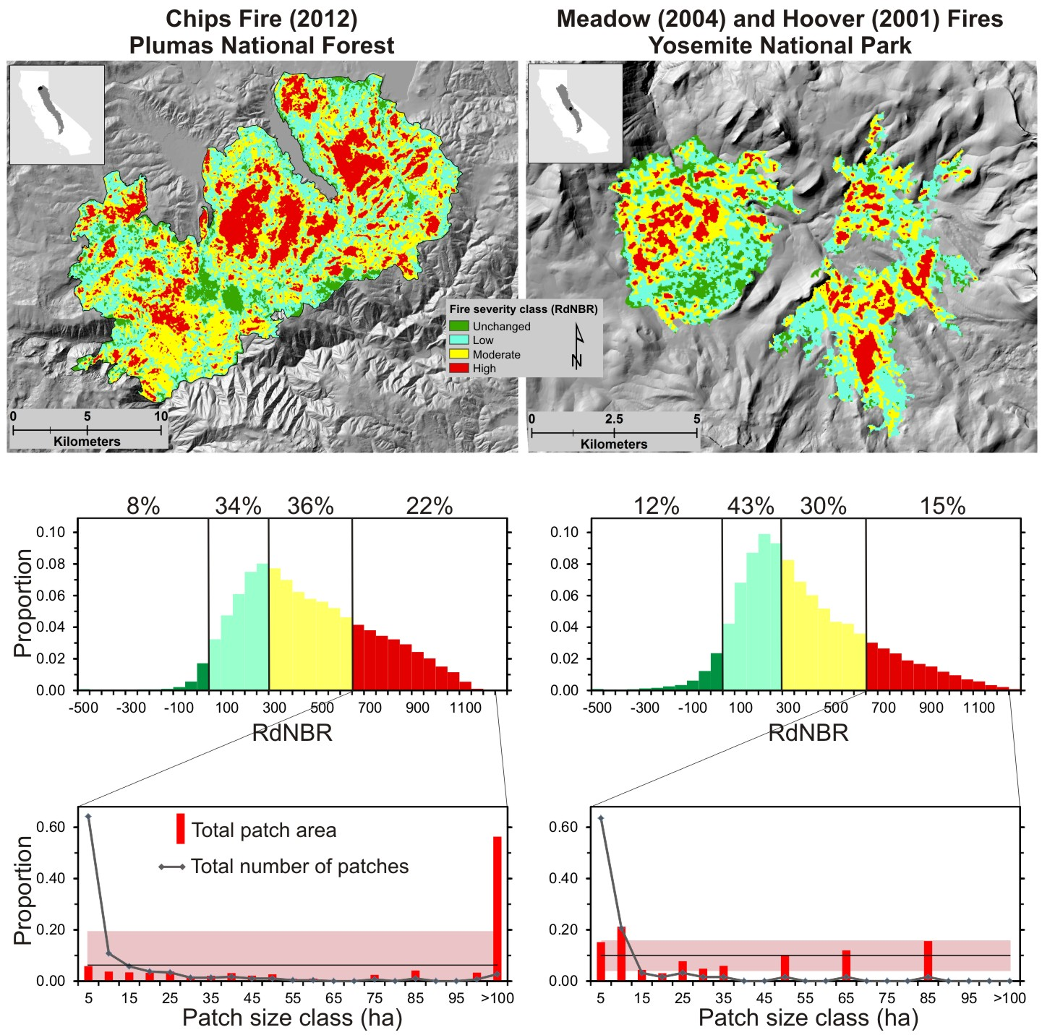

Figure 2

